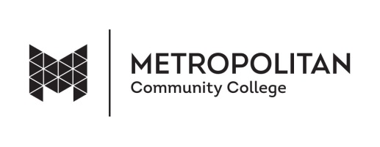
CONSENT AND RELEASE FORM
I HEREBY GIVE MY CONSENT FOR Metropolitan Community College or its agency to use my name, likeness, photograph and/or comments. I understand these will be used exclusively for the College without compensation, be it publications, advertising, television, film, radio, Internet or other appropriate communication or educational media.
I sign this of my own free will.

Name (please print)

Date

Address

City/State/Zip

Phone

Email

Signature

